G10037 – Long Range Fire Growth Analysis using Probabilistic Fire Analysis System (PFAS)

Starting Date | May 13, 2015
Starting DMC | 66 (forecast value at Bednesti station for 5/13)
Starting Fire Size (ha) | 11,400 ha (based on hand-drawn perimeter from MODIS hotspots)
Expected Fire Size (ha) | Confidence interval for area at risk: 22,251 – 171,861 ha

Weather Stations Included * | Elevation (m) | Approx. distance to fire ignition point (km) | Probability of Extinction** (15 days)
BEDNESTI | 858 | 18 | 0 %
CHILAKO | 814 | 26 | 8.1 %
NORTH CHILCO | 850 | 52 | 2.1%
* Stations are weighted inversely with distance from the fire
** Probability of reaching DMC < 20 (from one or more precipitation events) in given time period

Notes and Assumptions

- This fire was discovered on 5/08 from likely human causes (under investigation)
- Starting DMC of 66 was taken from the forecast value for Bednesti station
- The fire perimeter was mapped at approx. 3500 ha on 5/12 (am), but is believed to have experienced significant growth that afternoon and evening; the starting perimeter was estimated from MODIS hotspot detections, and is about 11,000 for the start of the simulation
- Fire spread modeled from entire perimeter
  - This may overestimate the fire spread potential along certain parts of the perimeter that are not active, but there is no way of knowing where all of the current hotspots are that could become active again during the simulation period
- Initial vegetation and fire behaviour: low-mid elevation (850 m) stands of older (~10 year) grey- attack beetle-killed pine, intermixed with white spruce and subalpine fir
  - Note – this simulation used the 2014 fuels layer, which is slightly out of date; many grey beetle-affected stands are typed as C-3, which may underpredict fire growth during certain conditions; this is an active research area, so fire behaviour in these stands is uncertain
  - To the N of the fire, several medium sized lakes may provide a partial barrier to fire spread; however, a column-driven fire could fairly easily spot over them.
  - This is an area of working forest, with many cutblocks, openings, and new plantations; they are mostly modeled as O-1a (matted grass), which may overestimate fire spread potential in these areas
- Fuels (Figure 1) modeled based on provincial fuel layer, with estimated May conditions based on local observations (D. Hicks, personal communication):
  - mixedwood fuels in leafed-out state (M-2) based on local intelligence, with grass fuels (O-1a/b) modeled as matted grass (O-1a), 60% cured
  - Grey-attack dead pine stands modeled as C-3 (unchanged from 2014 base fuels)

FBP Fuel Types (Figure 1)

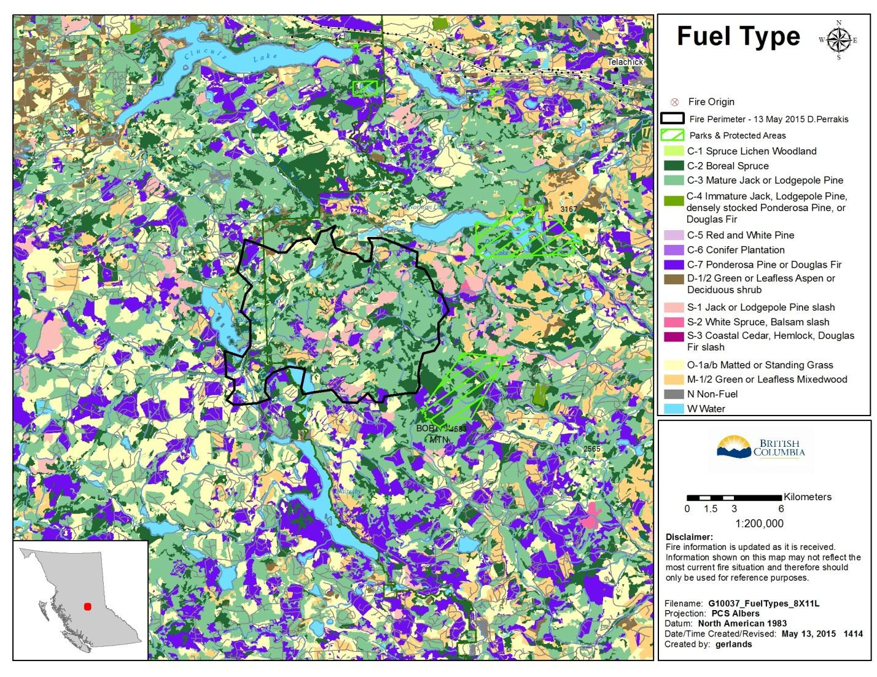

Notes and Assumptions (continued)

- Probability of extinction values from surrounding weather stations are less than 10%; there is little chance of a major precipitation event that would extinguish this fire, although some significant precipitation is likely in late May or early June
- Current forecasts for the region indicate continued warm and dry conditions this week, with light winds; this will contribute to continued fire growth.

- Resulting figure (Figure 2: ‘probability bull’s-eyes’) shows concentric levels of probability of fire arrival, from 100% (starting perimeter) down to a specified minimum probability (30%); this can be interpreted as follows:
  - There is a 70% chance that any subsequent fire growth will be contained within the outermost (dark green) figure shape within 15 spread days.
  - A 15-day PFAS simulation covers 15 days of active spread during conditions representative of this time of year

- We have very little experience running these simulations so early in the season, so if fire growth continues, we will have to re-run the simulation in 2-3 weeks’ time for an updated forecast
- During periods of exceptionally severe fire weather, it is possible for fires to breach the 70% probability region within less than 15 spread days

Modeler/Fire Behaviour Specialist

Dan Perrakis

15 Day area at risk with 70% probability (Figure 2):

